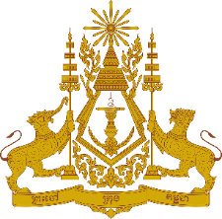
PERMANENT MISSION OF THE KINGDOM OF CAMBODIA
TO THE UNITED NATIONS AT GENEVA

Statement by
Mr. Phadora SOKHA, Second Secretary
Recommendations by Cambodia for Croatia at the 36th Session of the Universal Periodic Review Working Group
Tuesday, 10 November 2020
[Speaking Time: 1 min. and 15 sec.]

Madam President!
Cambodia welcomes the delegation of Croatia to the Third Cycle of the Universal Periodic Review and takes note of the Croatian national report presented.
Cambodia recognizes the efforts taken by the Croatian government to address gender-based violence, and to combat poverty and social exclusion.
Cambodia also welcomes the adoption of the new law on Protection Against Domestic Violence, with broad range the definition of domestic violence. The increasing number of women participating in government sector is commendable.
In the constructive spirit, Cambodia would like to put forward two recommendations to Croatia as follow:
- Consider enhancing additional steps to eliminate gender-based discrimination in the work environment
- Enhance further efforts to prevent and eliminate all forms of hate speech and hate crimes for members of national minorities
Finally, I wish the delegation of Croatia every success in this review.

I Thank you, Madam President!

