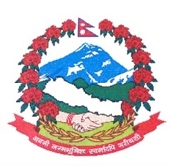
Statement by the delegation of Nepal
36th session of the Working Group on the Universal Periodic Review
UPR of the United States of America
9 November 2020
Time: 55 sec
Words: 127
Madam President,

Nepal warmly welcomes the delegation of the United States of America to the third cycle of the UPR. We thank them for presenting the national report.

Nepal commends the unwavering commitment of the United States to the inalienable rights of all individuals.

We note the US legislative and policy measures and appreciate their progress towards the robust protection of human rights.

We encourage the United States to further enhance their efforts for improving racial disparities and promoting social inclusion.

While wishing the United States a successful review, we recommend the following for their consideration:

- Consider ratification of core international human rights instruments, including CEDAW and CRC; and
- Consider establishing an independent national human rights institution in accordance with the Paris Principles.

Thank you.

