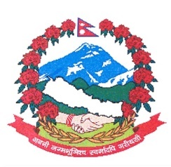
Statement by the delegation of Nepal
36th session of the Working Group on the Universal Periodic Review
UPR of Marshall Islands
9 November 2020
Time: 1 min 35 secs
Words: 177
Madam President

Nepal warmly welcomes the delegation of Marshall Islands to the third cycle of UPR.

We thank them for the presentation of its National report and commend their constructive engagement with the human rights bodies and mechanisms for the promotion and protection of human rights.

Nepal welcomes Marshall Islands for ratifying various core international human rights instruments including ICCPR and CERD since the last review. We also appreciate the development of necessary legal frameworks to ensure the effective implementation of the core instruments at national level.

Nepal appreciates Marshall Islands for its engagement in leading global call for climate action and climate justice. We commend the adoption of its Climate Strategy 2050 charting a carbon neutral sustainable development path for the country.

While wishing Marshall Islands a successful review, we recommend the following for their consideration:

- Continue its efforts to implement legislative and policy measures on child rights protection.
- Continue its efforts to mobilize international cooperation and support to address the impacts of climate change on socio-economic conditions of women and children.

Thank you.

