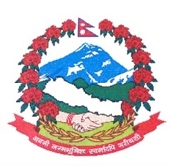
Statement by the delegation of Nepal
36th session of the Working Group on the Universal Periodic Review
UPR of Maldives
4 November 2020
Time: 1 min 10 secs
Words: 132
Madam President,

Nepal warmly welcomes the delegation of Maldives to the third cycle of UPR.

We thank them for the presentation of national report.

Nepal appreciates the firm commitment of Maldives to gender equality and child protection.

We welcome the implementation of Gender Equality Act.

We also welcome the formulation of Strategic Action Plan to enhance the implementation of SDGs in Maldives.

Nepal commends Maldives for adopting holistic measures to build climate resilient infrastructure and developing national strategic framework to mobilize international climate finance to address climate change.

While wishing Maldives a successful review, we recommend the following for their consideration:

- Continue de facto moratorium on the death penalty and consider steps towards its legal abolition.

- Continue to give priority to address the issue of trafficking in persons.

Thank you.

