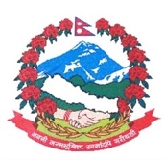
Statement by the delegation of Nepal
36th session of the Working Group on the Universal Periodic Review
UPR of Malawi
3 November 2020
Time: 1 min 15 secs
Words: 127
Madam President,

Nepal warmly welcomes the delegation of Malawi to the third cycle of UPR and appreciates the presentation of its comprehensive national report.

Nepal welcomes Malawi’s Gender Equality Act Implementation and Monitoring Plan to provide gender equality, integration, influence, empowerment, dignity and opportunities for men and women in all functions of society

We also commend Malawi’s National Multi-Sector Nutrition Policy to prevent malnutrition in children under five, adolescent girls, school-going children and other vulnerable groups.

While wishing Malawi a successful review, we recommend the following for their consideration:

- Continue de facto moratorium on the death penalty and further take steps towards its legal abolition.
- Continue to take measures for promoting gender equality and ending all forms of gender based violence and discrimination.

Thank you.

