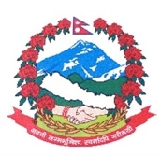
Statement by the delegation of Nepal
36th session of the Working Group on the Universal Periodic Review
UPR of Libya
11 November 2020
Time: 1 min
Words: 144
Madam President,

Nepal warmly welcomes the delegation of Libya to the third cycle of UPR.

We thank them for the presentation of national report.

We appreciate the efforts of Libya to empower women and promote their participation in political, economic and public life.

We take positive note of the provision of fixed quota allocated for the representation of women in elections to the General National Congress as well as to the Chamber of Deputies and the Constituent Assembly.

We encourage Libya to enhance its efforts for strengthening state institutions and improving administration of justice and rule of law.

While wishing Libya a successful review, we recommend the following for their consideration:

- Continue to take necessary measures to eliminate the smuggling and trafficking networks and protect migrants from exploitation and abuse.
- Continue to enhance measures to prevent sexual and gender-based violence.

Thank you.

