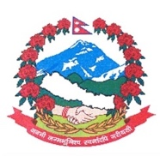
Statement by the delegation of Nepal
36th session of the Working Group on the Universal Periodic Review
UPR of Honduras
5 November 2020
Time: 1 min 20 secs
Words: 158
Madam President,

Nepal warmly welcomes the delegation of Honduras to the third cycle of UPR.

We thank them for the presentation of national report highlighting the advances in the promotion and protection of human rights.

We welcome the creation of the National Commission for the 2030 Agenda for Sustainable Development for the effective implementation of SDGs.

We take encouraging note of impressive participation of women in civil service and in political sphere.

We welcome the adoption of the Strategic Plan against Commercial Sexual Exploitation and Trafficking in Persons.

Initiatives carried out by Honduras for the protection of migrants including support to retuning migrants for local reintegration are commendable.

While wishing Honduras a successful review, we recommend the following for their consideration:

- Continue its efforts to strengthen the functioning of national human rights institutions and mechanisms.
- Continue to take measures to prevent and combat domestic and sexual violence and provide assistance and protection to victims.

Thank you.

