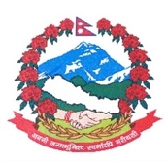
Statement by the delegation of Nepal
36th session of the Working Group on the Universal Periodic Review
UPR of Bulgaria
6 November 2020
Time: 1 min 10 sec
Words: 138
Madam President,

Nepal warmly welcomes the delegation of Bulgaria to the third cycle of UPR and thanks them for the presentation of national report.

We welcome Bulgaria’s National Action Plan for the Promotion of Equality between Women and Men.

We commend Bulgaria’s legal and institutional frameworks that shape the economic opportunities of women and ensure equal access and inclusive participation of women in all programmes, projects and measures in the labour market.

We take note of measures Bulgaria has taken for maintaining the necessary conditions in the facilities for detention of foreigners.

While wishing Bulgaria a successful review, we recommend the following for their consideration:

- Continue to implement measures in combating human trafficking and enhancing protection for victims.
- Continue its efforts to improve equality in education, including for Roma children, and in rural areas.

Thank you.

