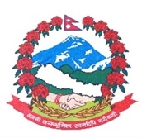
Statement by the delegation of Nepal
36th session of the Working Group on the Universal Periodic Review
UPR of Andorra
5 November 2020
Time: 2 min
Words: 142
Madam President,

Nepal warmly welcomes the delegation of Andorra to the third cycle of UPR.

We thank them for the presentation of national report.

We note the extended mandate of the Ombudsman institution for the promotion and protection of human rights in Andorra.

Nepal welcomes Andorra’s adoption of the strategic plan for the implementation of the Sustainable Development Goals.

We are encouraged by legal reforms on equal treatment and non-discrimination that regulates the right to equality and provides protections for women and vulnerable groups in case of violation or discrimination.

Advances made in children’s rights protection, including in education and health, are commendable.

While wishing Andorra a successful review, we recommend the following for their consideration:

- Continue its efforts to enhance gender equality and non-discrimination.
- Continue to implement measures in combating human trafficking and enhancing protection for victims.

Thank you.

