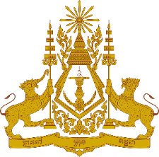
PERMANENT MISSION OF THE KINGDOM OF CAMBODIA
TO THE UNITED NATIONS AT GENEVA

Intervention by
Ambassador and Permanent Representative Sokkhoeurn An
At the 36th Universal Periodic Review (UPR) Working Group
The UPR on the United States of America
09 November 2020, Geneva

Madam President!

- While noting commitment of the US to the principle that leadership in the field of human rights is by example, my delegation is concerned that death penalty remains legal under the federal law. In addition, a number of international human rights treaties as to persons with disability, discrimination against women, and child’s rights have not been ratified by the US.

- My delegation read with concern report of the UN Special Rapporteur as to journalists attacked, harassed, arrested and detained in the course of their work covering protests in the US against systematic racism and police brutality.

- In the constructive spirit, Cambodia would like to offer two recommendations to the US delegation.
- First, consider legislatively abolishing the practice of death penalty in all states; and
- Second, carry out additional anti-discrimination trainings of government officials at all levels and systematically.

I thank you, Madam President!

-----------------------------------

