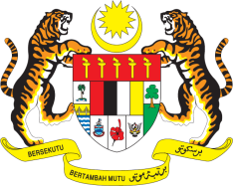

STATEMENT BY MALAYSIA
REVIEW OF THE UNITED STATES OF AMERICA
36TH SESSION OF THE UPR WORKING GROUP
2-13 NOVEMBER 2020

Madam President,

Malaysia thanks the delegation of the USA for its presentation.

- Based on all reports submitted, Malaysia puts forth the following recommendations:

  - Consider establishing an independent national human rights institution in line with the Paris Principles;

  - Ensure a systematic accountability and full, prompt redress for victims in cases of police misconduct and brutality;

  - Prohibit torture in detention and ensure detainees have access to fair trials and full redress;

  - Ensure universal access to sexual and reproductive health information, education and services for all; and

  - Strengthen efforts to address discrimination, racial profiling, religious intolerance and incidences of Islamophobia including those perpetrated by authorities.

- Malaysia wishes the USA a successful review.

Thank you Madam President.

GENEVA
9 November 2020

