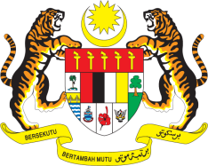

STATEMENT BY MALAYSIA
REVIEW OF PANAMA
36TH SESSION OF THE UPR WORKING GROUP
2-13 NOVEMBER 2020

Madam President,

Malaysia would like to extend its appreciation to the delegation of Panama for the presentation of its national report.

2. Malaysia is pleased that Panama has taken efforts to promote the rights and welfare of specific groups of its population. Among others, we note that Panama had made progress in promoting women’s inclusion in the workplace, reducing gap in wage and has taken efforts to encourage women to partake in economic activities. We further note that Panama had adopted the National Strategy for the Prevention of Violence against Children and Adolescents which is also strategically aligned with the Sustainable Development Goals. We are confident that the National Secretariat for Disabilities will continue undertaking its mandate to promote the rights of persons with disabilities. We welcome the allocation of necessary resources to facilitate and support the meaningful participation of persons with disabilities in daily life activities.

3. In the spirit of constructive engagement, my delegation would like to propose the following two recommendations for Panama’s consideration:

3.1. One: Undertake more efforts to prevent poverty among persons with disabilities by implementing inclusive social system that also provides retirement scheme or other financial support; and

3.2. Two: Guarantee as well as increase women’s participation in public and political spheres.

4. We wish Panama success in its efforts in the promotion and protection of human rights.

I thank you Madam President.

GENEVA
3 November 2020

