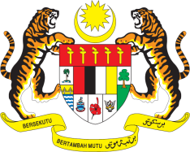

STATEMENT BY MALAYSIA
REVIEW OF MONGOLIA
36TH SESSION OF THE UPR WORKING GROUP
2-13 NOVEMBER 2020

Madam President,

Malaysia thanks Mongolia for the presentation of its national report to the 36th Session of the UPR Working Group.

- Malaysia commends Mongolia for making numerous notable progresses in the promotion and protection of human rights in the country. The robust, transparent and inclusive approach adopted by Mongolia towards implementing its human rights commitments has translated into further advancements in the protection of rights and interests of vulnerable populations including children, women, people with disabilities and older persons.

- We welcome Mongolia’s proactive measures including partnerships with States and UN agencies in addressing its human rights challenges. We are also pleased that Mongolia had taken efforts to implement the recommendations made by Malaysia during its Second UPR. We hope the efforts will be further strengthened.

- In the spirit of constructive engagement and to further support Mongolia’s endeavors in combating trafficking in persons, Malaysia recommends that Mongolia increases the protection of and provide redress to victims of trafficking, including access to rehabilitation and shelters.

- We wish Mongolia every success in its Third UPR.

I thank you Madam President.

GENEVA
4 November 2020

