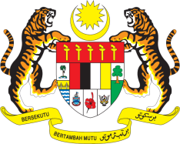

STATEMENT BY MALAYSIA
REVIEW OF MARSHALL ISLANDS
36TH SESSION OF THE UPR WORKING GROUP
2-13 NOVEMBER 2020

Madam President,

Malaysia thanks the delegation of Marshall Islands for the presentation of its national report to the 36th Session of the UPR Working Group.

- Noting the progress made since its last review, including enactment and implementation of numerous national legislations and policies, in the spirit of constructive engagement, Malaysia hopes that the following recommendations will be duly considered and accepted by the Government as part of its efforts to further advance human rights for its people:

First: Establish a national human rights institution in accordance with the Paris Principles;

Second: Ensure access to justice for women by addressing physical and economic barriers in particular women residing in the outer islands;

Third: Strengthen the judicial system, including through the allocation of sufficient human, technical and financial resources as well as systematic capacity-building on women’s rights and gender equality for relevant authorities;

Fourth: Expand national cancer prevention programme to address the effects of nuclear testing, which had had a disproportionate impact on women’s health, and ensure that the health sector is adequately funded; and

Fifth: Take immediate steps to guarantee access to clean water and sanitation for all and ensure that sanitation facilities are adequately available.

- Malaysia wishes Marshall Islands a successful review.

I thank you Madam President.

GENEVA
9 November 2020

