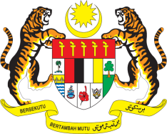

STATEMENT BY MALAYSIA
REVIEW OF MALDIVES
36TH SESSION OF THE UPR WORKING GROUP
2-13 NOVEMBER 2020

Madam President,

Malaysia thanks Maldives for the presentation of its national report.

- Malaysia commends Maldives for making meaningful progress since its last UPR to better promote and protect the human rights of its people, including through law reforms during the reporting period.

- We would like to commend particularly, the sustained efforts of the Government in promoting gender equality including through the Gender Equality Act. We recommend that the Government collaborate closer with all stakeholders to find ways to remove structural or policy barriers that can impede women from contributing more in the workplace and in all sectors.

- We are also pleased with the SME Development Finance Corporation, which aims to encourage participation of women in the business sector. Similarly, Malaysia is pleased to note that the Government has also taken measures to assist young people to venture into micro, small and medium enterprises. We recommend that the Government continues to implement further sustainable programmes and initiatives in this regard.

- Malaysia wishes Maldives every success in the implementation of its Third UPR.

I thank you Madam President.

GENEVA
4 November 2020

