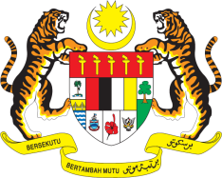

STATEMENT BY MALAYSIA
REVIEW OF MALAWI
36TH SESSION OF THE UPR WORKING GROUP
2-13 NOVEMBER 2020

Madam President,

Malaysia thanks Malawi for the presentation of its national report to the 36th Session of the UPR Working Group.

- Malaysia commends Malawi for making progress in the promotion and protection of human rights in the country. The inclusive approach adopted by Malawi towards implementing its human rights commitments is manifested in the various legislation and policy frameworks enacted and amended by the Government.

- Noting the progress made, Malaysia is aware that Malawi has indicated in its national report that it faces several challenges especially on the social and economic rights front. Malawi has also underlined that technical assistance is required in the follow-up of UPR recommendations. We hope that necessary assistance including those under the Council’s ambit will be made available accordingly.

- Further, Malaysia hopes that the following recommendations will be duly considered and accepted by the Government as part of its efforts to further advance human rights for its people:

  - Continue to ensure access to quality education for all;
  - Intensify efforts to combat poverty, particularly in areas where poverty is most prevalent and widespread; and
  - Undertake more robust measures to address factors contributing to women affected by poverty including by ensuring adequate social protection and safeguards, job opportunities and skills training.

I thank you Madam President.

GENEVA
3 November 2020

