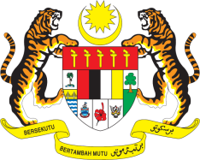

STATEMENT BY MALAYSIA
REVIEW OF LIBYA
36TH SESSION OF THE UPR WORKING GROUP
2-13 NOVEMBER 2020

Madam President,

Malaysia thanks Libya for its national report.

- Malaysia welcomes the recent signing of a ceasefire agreement by the Libyan parties. This is a crucial step towards peace and stability and the Government of National Accord should continue its efforts to tackle all causes of the armed conflict.

- In the framework of Libya’s review at this session, Malaysia takes note that Libya has taken efforts to provide education by ensuring educational institutions are evenly distributed and accessible to everyone. We also note that Libya is on the right track to achieve gender parity in the education sectors. We recommend the following:

One: Take all necessary measures to protect the educational environment including by restoring educational institutions that had been destroyed; and

Two: Continue efforts to provide quality education by collaborating with relevant stakeholders including United Nations agencies.

- We also take note of Libya’s National Plan to end violence against women. Malaysia recommends that Libya imposes stricter enforcements to curb sexual abuse and exploitation for women in detention and migrant women.

- Malaysia wishes Libya a successful review.

Thank you Madam President.

GENEVA
11 November 2020

