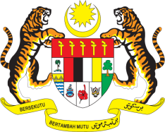

STATEMENT BY MALAYSIA
REVIEW OF LIBERIA
36TH SESSION OF THE UPR WORKING GROUP
2-13 NOVEMBER 2020

Madam President,

Malaysia thanks Liberia for the presentation of its national report, which is a result of multi-stakeholder consultation involving the government, members of the Independent National Commission on Human Rights (INCHR), representatives of civil society organisations, as well as development partners, including the United Nations. We hope this whole-of-society and constructive approach will be sustained in the implementation of recommendations following Liberia review today. We also welcome recent developments including Liberia’s first national Human Rights Action Plan adopted in 2019.

- In the spirit of constructive engagement within the UPR framework, Malaysia recommends the following:

  - Effectively implement the national Human Rights Action Plan;

  - Continue taking measures to ensure quality education for all, including through the implementation of policies and programmes related to the right to education;

  - Adopt a robust strategy to promote participation of women in public affairs and increase presence of women in decision-making positions; and

  - Step up efforts to address the root causes of trafficking in women and girls, and ensure the rehabilitation and social integration of victims by providing them with access to shelters, legal, medical and psychosocial assistance and alternative income generating opportunities.

I thank you Madam President.

GENEVA
2 November 2020

