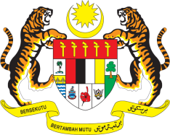

STATEMENT BY MALAYSIA
REVIEW OF HONDURAS
36TH SESSION OF THE UPR WORKING GROUP
2-13 NOVEMBER 2020

Madam President,

Malaysia thanks Honduras for the presentation of its national report to the 36th Session of the UPR Working Group.

- Malaysia has considered all reports submitted to the UPR Working Group and within this framework, we recommend the following:

  - Establish accessible, transparent and effective consultation and complaint mechanisms for communities affected by mining and commercial projects;

  - Ensure that all children had access to education and put in measures to provide quality education including by allocating greater budgetary resources;

  - Strengthen policies to ensure children remain in school;

  - Establish policies and mechanisms to prevent and eradicate child labour, including support programmes for low income families;

  - Implement stricter enforcements and punitive laws for offences of sexual violence against women that are proportionate with the crimes committed; and

  - Prioritize investment in the national health system in order to guarantee the availability of free, universal public health care for all.

- Malaysia wishes Honduras a successful review.

I thank you Madam President.

GENEVA
5 November 2020

