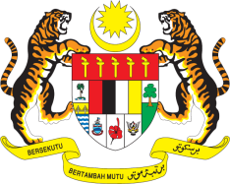

STATEMENT BY MALAYSIA
REVIEW OF CROATIA
36TH SESSION OF THE UPR WORKING GROUP
2-13 NOVEMBER 2020

Madam President,

Malaysia thanks Croatia for the presentation of its national report.

- Malaysia acknowledges the steps taken by Croatia in combating domestic violence and violence against women through its National Strategy for Protection against Domestic Violence 2017-2022. The national strategy testifies Croatia’s continued commitment to fulfil the rights of women. In this connection, we also look forward to a robust national policy for gender equality.

- Malaysia commends Croatia for taking efforts to improve healthcare services including through allocation of resources to support specialist offices in undeveloped areas. Malaysia further commends the decrease in the number of pending housing care requests from 1,167 in December 2017 to 310 in December 2018. We hope that the new Act on Housing Care in the Assisted Areas will be effectively and fully implemented.

- In the spirit of constructive engagement, Malaysia recommends the following:

One: Increase efforts to ensure non-discriminatory access to adequate housing, social benefits and services for all victims of past conflicts under its jurisdiction, including the Roma; and

Two: Ensure rights-compliant approach to the mental health-care system throughout the country.

- Malaysia wishes Croatia a successful review.

I thank you Madam President.

GENEVA
10 November 2020

