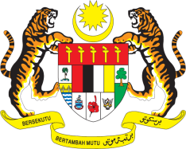

STATEMENT BY MALAYSIA
REVIEW OF BULGARIA
36TH SESSION OF THE UPR WORKING GROUP
2-13 NOVEMBER 2020

Madam President,

Malaysia thanks Bulgaria for the presentation of its national report. We value Bulgaria’s commitment to the UPR process, which is also testified in its voluntary UPR mid-term report submitted in December 2018.

- We are pleased to note the adoption of National Action Plan for the Promotion of Equality between Women and Men (2019-2020), which among others would improve livelihood of women, including women with disabilities through provisions of vocational trainings and business activities. We hope the full and effective implementation of this Plan would improve the legal framework to address violence against women and domestic violence in the country. We welcome the efforts by the National Commission for Combating Trafficking in Human Beings, including the mapping of vulnerable groups in order to detect specific trends and forms of recruitment, exploitation and destinations for trafficking.

- In the spirit of constructive engagement within the UPR framework, Malaysia recommends the following:

  - Raise public awareness on respect for diversity and undertake legislative reforms to further address intolerance and hate speech;
  - Allocate adequate resources to ensure full implementation of the National Programme for improving mother and child healthcare; and
  - Promote the employment of women in fields where they remain underrepresented and continue efforts to address wage gap between men and women.

I thank you Madam President.

GENEVA
6 November 2020

