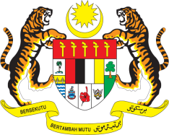

STATEMENT BY MALAYSIA
REVIEW OF BELARUS
36TH SESSION OF THE UPR WORKING GROUP
2-13 NOVEMBER 2020

Madam President,

Malaysia thanks Belarus for the presentation of its national report.

- In the framework of the Universal Periodic Review of Belarus, Malaysia takes note of the measures undertaken to implement recommendations from its second UPR including those made by Malaysia. Among others, the placement of experts/educational psychologists at care centres are welcoming steps that could further strengthen physio-socio support to children. We look forward to further advancement of children welfare and their wellbeing and hope that the National Commission on the Rights of the Child will continue to undertake efforts towards this end.

- In the spirit of constructive engagement, Malaysia recommends the following:

  - Continue taking efforts to establish a national human rights institution in accordance with the Paris Principles, as previously recommended;

  - Consider developing a comprehensive strategy for preventing, combating all forms of violence against children and put in place robust measures to effectively implement the national plan of action to advance rights of children; and

3.3. Continue taking steps to combat violence against women including through legislative reforms.

- Malaysia wishes Belarus a successful review.

I thank you Madam President.

GENEVA
2 November 2020

