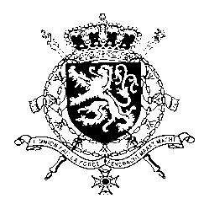
Représentation permanente de la Belgique auprès des Nations Unies et auprès des institutions spécialisées à Genève

WG UPR – Mongolia
Belgian intervention
3 November 2020

Madam President,

Belgium commends the government of Mongolia for the abolishment of the death penalty for all crimes in the new Criminal Code as well as progress made in the advancement of children’s rights. However, Belgium remains convinced that more can be done in these areas.

Therefore, Belgium recommends the government to:

R1. Establish a legislative framework that fully guarantees the right to privacy for children, including victims of sexual violence;

R2. Adopt a National Action Plan aiming at the elimination of child labour, supported by sufficient human, technical and financial resources.

As a strong opponent of the death penalty, Belgium recommends Mongolia to:

R3 Remove any reference to the death penalty from the constitution.

Thank you, Madam President.

