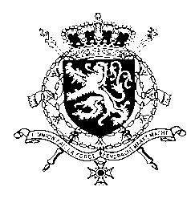
Représentation permanente de la Belgique auprès des Nations Unies et auprès des institutions spécialisées à Genève

WG UPR – Marshall Islands
Belgian intervention
9 November 2020

Madam President,

Belgium welcomes the delegation of the Republic of the Marshall Islands and wishes it every success during its third UPR.

We congratulate the Marshall Islands for being an active member during its first term in the Human Rights Council, and applaud the ratification of no less than 7 human rights instruments since 2018.

Nevertheless, Belgium is convinced more progress can be made to increase the protection of human rights in line with the core international human rights treaties.

Belgium therefore recommends the government to:

R1. Intensify efforts to raise awareness, including through educational and media campaigns, of the criminal nature of gender-based and domestic violence, targeting both men and women in order to eradicate its social acceptance and encourage reporting.

R2. Strengthen the implementation of legislation against exploitation and trafficking in persons, including children, and ensure that perpetrators are prosecuted, convicted and sentenced to adequate penalties.

As a strong opponent of the death penalty, Belgium recommends the government to:

R3. Ratify the Second Optional Protocol to the Covenant on Civil and Political Rights, aiming at the abolition of the death penalty.
Thank you, Madam President.

