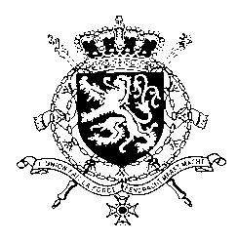
Représentation permanente de la Belgique auprès des Nations Unies et auprès des institutions spécialisées à Genève

WG UPR 36 – Malawi
Belgian intervention
3rd of November 2020

Madam President,

Belgium appreciates Malawi’s engagement with the UPR. We acknowledge the progress made by Malawi since its previous UPR and applaud the democratic transfer of power in 2019. However, Belgium is convinced that further progress can still be achieved to increase the protection of human rights in line with the core international human rights treaties.

Belgium therefore recommends the government of Malawi to:

R1. Harmonize laws and adequately fund the Child Marriage Strategy (2018-23) with a view to take all necessary measures to end child, early and forced marriage;

R2. Accurately map and thoroughly investigate reports of alleged extrajudicial killings and suspicious deaths in police custody, and if necessary, establish a process of accountability for persons involved;

R3. Ensure the effective implementation of the Gender Equality Act, and in particular increase efforts to improve the literacy and education of women with a view to broaden their formal employment opportunities.

Thank you, Madam President.

