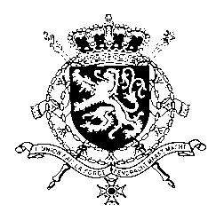
Représentation permanente de la Belgique auprès des Nations Unies et auprès des institutions spécialisées à Genève

WG UPR – Honduras
Belgian intervention
5 November 2020

Madam President,

Belgium welcomes the outlawing of marriages of minors by the government of Honduras in 2017.

We hope that efforts against violent crimes, corruption and impunity will continue after the end of the Mission to Support the Fight Against Corruption and Impunity in Honduras (MACCIH), especially seeing the violence committed against human rights defenders, journalists and environmentalists.

Belgium is also deeply concerned about the persistent violence against women, particularly the high number of rapes and femicides.

Belgium therefore recommends the government of Honduras to:

R1. Ensure thorough, prompt, impartial and independent investigations into all attacks, threats and assaults against human rights defenders, and bring to justice those suspected of criminal responsibility for such crimes;

R2. Include in the draft National Protocol for the Care of Victims of Sexual Violence international standards regarding the management and treatment of rape, including access to emergency contraception, so that it can be implemented promptly;

R3. Redouble its efforts to prevent and combat all acts of violence against women, to punish those responsible and to provide assistance and protection to victims, including through the adoption of a comprehensive law on violence against women.

Thank you, Madam President.

