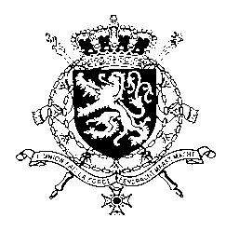
Représentation permanente de la Belgique auprès des Nations Unies et auprès des institutions spécialisées à Genève

WG UPR 36 – Croatia
Belgian intervention
10th of November 2020

Madam President,

Belgium congratulates Croatia with the progress made since its previous UPR and welcomes the commitment of the government of Croatia to a policy of national reconciliation and encourages it to continue on this path. Notwithstanding these achievements, there is still room for progress, as observed by several UN human rights mechanisms.

Belgium therefore recommends the government of Croatia to:

R1. Take concrete steps to expedite the prosecution of cases of war crimes and crimes against humanity and ensure that all such cases are prosecuted in a non-discriminatory manner, regardless of the perpetrator’s ethnicity;

R2. Adopt a comprehensive approach to prevent and address violence against women in all its forms and take concrete steps to align the national legislative and administrative framework with the standards set out in the Istanbul Convention;

R3. Conduct awareness-raising and educational campaigns aimed at the general public and provide appropriate training to public officials to combat stereotypes, prejudices and hate speech against LGBTI and ensure that acts of violence against LGBTI persons are effectively investigated and perpetrators prosecuted and sanctioned.

Thank you, Madam President.

