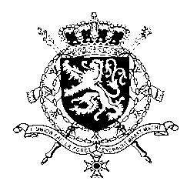
Représentation permanente de la Belgique auprès des Nations Unies et auprès des institutions spécialisées à Genève

WG UPR 36 – Belarus
Belgian intervention
2nd of November 2020

Madam President,

Belgium thanks the delegation of Belarus for its presentation. Belgium is however gravely concerned about the deterioration of human rights in Belarus since its previous UPR.

We strongly condemn the ongoing disproportionate and violent post-election crackdown carried out by Belarusian authorities against peaceful protesters, political activists, journalists and media workers. The use of purported national security concerns as a pretext to deny individuals their human rights, including the freedoms of expression and peaceful assembly must stop.

Belgium therefore recommends the government of Belarus to:

R1. Refrain from intimidation, harassment, arbitrary arrest and disproportionate use of force against people exercising their right to freedom of expression and peaceful assembly.

R2. Immediately and without any conditions release all political prisoners and provide them with full rehabilitation.

As a strong opponent of the death penalty, Belgium reiterates its recommendation of the previous UPR:

R3. Ratify the Second Optional Protocol to the International Covenant on Civil and Political Rights (ICCPR) and as an interim measure, establish a moratorium on executions as soon as possible.

Thank you, Madam President.

