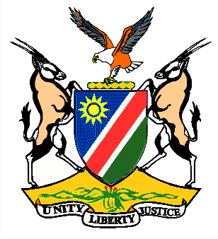

Statement by H.E. Penda A. Naanda, Ambassador/PR, during the Interactive Dialogue on the Universal Periodic Review of Liberia 02 November 2020

Thank you, Madam. President,
- Namibia warmly welcomes the esteemed delegation of the Republic of Liberia. We congratulate and thank them for submitting a comprehensive third cycle national report as well as for the additional information provided today.
Madam President,
- The year 2020 marks important milestones in the Gender Equality and Women’s Empowerment Calendar, as we inter alia commemorate the 25th Anniversary of the Beijing Declaration and Platform for Action and the 20th Anniversary of UN Security Council Resolution 1325 on Women, Peace and Security. These anniversaries offer us with a unique opportunity to close the remaining gaps that hinder successful implementation of international instruments that are aimed at protecting the rights of women and girls around the world. Thus, while commending Liberia for the positive strides made in improving the human rights of its citizen during the period under review, we make the following recommendations to Liberia for consideration:

  - Amend customary and statutory laws in order to eliminate all forms of discrimination against women and girls.

  - Take further measures aimed at eliminating harmful practices especially, female genital mutilation, that violate the rights of women and girls.

- We wish the delegation of Liberia a successful review.

- I thank you Madam President.

