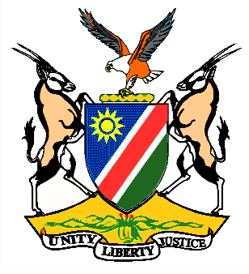

Statement by H.E. Penda A. Naanda, Ambassador/PR, during the Interactive Dialogue on the Universal Periodic Review of Jamaica 11 November 2020

- Thank you, Madam. President,

- Namibia extends a warm welcome to the delegation of Jamaica to the 3rd Cycle of the UPR and thanks them for the national report presented today. We commend Jamaica for human rights-related legislative and institutional initiatives undertaken since the last review. These include, inter alia, joining the Regional Agreement on Access to Justice in Environmental Matters and the establishment of the Inter-Ministerial Committee on Human Rights.

- In the spirit of constructive engagement, we make the following recommendations for consideration by Jamaica:
- Establish a National Human Rights Institution, in accordance with the Paris Principles.
- Ratify the Optional Protocol to the Convention on the Elimination of All Forms of Discrimination against Women.
- We wish the delegation of Jamaica a successful review.
- I thank you Madam. President

