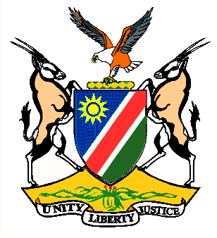

Statement by H.E. Penda A. Naanda, Ambassador/PR, during the Interactive Dialogue on the Universal Periodic Review of Malawi 03 November 2020

Thank you, Madam. President,
- Namibia warmly welcomes the esteemed delegation of the Republic of Malawi and thank them for submitting and introducing the national report which, amongst other things, elaborates on the measures taken to implement the accepted recommendations from the last UPR. We commend Malawi for the achievements made especially, the measures taken thus far to improve the rights of children, women and girls and other vulnerable groups. There, however, remains room for improvement and in the spirit of constructive dialogue we make the following recommendations to Malawi for consideration:

  - Ratify the Optional Protocol to the Convention on the Elimination of All Forms of Discrimination against Women.
  - Ratify the Optional Protocol to the Convention on the Rights of Persons with Disabilities.
- We wish the delegation of Malawi a successful review.

- I thank you Madam President.

