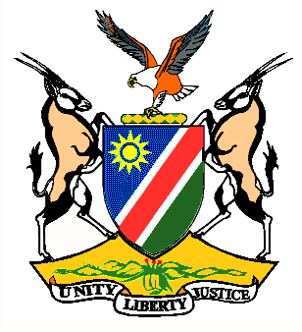

Statement by H.E. Penda A. Naanda, Ambassador/PR, during the Interactive Dialogue on the Universal Periodic Review of Libya 11 November 2020

Thank you, Madam. President,
- Namibia warmly welcomes the esteemed delegation of Libya, to the 3rd Cycle of the UPR and thanks them for the report presented today. We commend Libya that, despite the complex security and other challenges faced during the period under review, the Country continues to promote measures aimed at improving the human rights situation on its territory.
- In the spirit of constructive dialogue, we make the following recommendations for consideration by Libya:

  - Ratify and strictly implement the Arms Trade Treaty without delay.
  - Ratify the Second Optional Protocol to the International Covenant on Civil and Political Rights, aiming at abolition of the death penalty.
  - Consider commuting all current death penalty sentences to other forms of punishment.
  - Establish a fully independent judicial mechanisms to investigate, prosecute and punish perpetrators of war crimes and other human rights violations.
We wish the delegation of Libya a successful review.
I thank you Mr. President.

