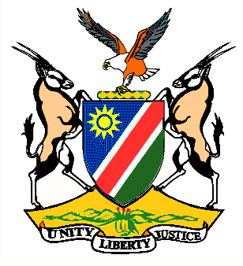

Statement by H.E. Penda A. Naanda, Ambassador/PR, during the Interactive Dialogue on the Universal Periodic Review of the United States of America 09 November 2020

Thank you, Madam. President,
- Namibia warmly welcomes the esteemed delegation of the United States of America. We thank the United States of America for their commitment to the UPR process and for submitting a comprehensive third cycle national report.
Madam President,
- This UPR comes at a time when millions of Americans are exercising their fundamental right to vote at a time when the world continues to grapple with the deadly COVID-19 pandemic. We therefore commend the U.S. for its standfast commitment to democracy and wish all Americans the best as they go through this election period.
- In the spirit of constructive dialogue we make the following recommendations for consideration by the United States of America:
  - Ratify the Convention on the Elimination of All Forms of Discrimination against Women.
  - Adopt legislation that aims to reduce incidents of profiling by law enforcement.
  - Commit to ending the death penalty federally and create incentives for states to enact similar bans.
- We wish the delegation of the United States a successful review.

- I thank you Madam President.

