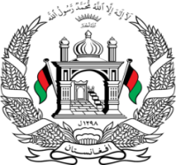
Permanent Mission of Islamic Republic of Afghanistan
36th Session of the UPR Working Group

Statement on the Review of the United States of America

9 November 2020 at 14:30

Mr./Mme. (Vice) President,

Afghanistan welcomes the distinguished delegation of the United States of America. We express our appreciation for their engagement with the UPR.

In the spirit of constructive engagement, we recommend the United States to:

Ratify the Convention on the Rights of the Child and the Convention on the Rights of Persons with Disabilities.

Afghanistan joins other countries in expressing concerned over the rise of racism, xenophobia and discrimination on the basis of race and religion, incitement of racial discrimination and hatred in political speech to marginalize racial, ethnic and religious minorities.

Finally, Afghanistan encourages the United States to continue to promote and protect human rights in the context of addressing COVID-19 and wishes the United States Every success in the UPR review process.

I thank you, Mr./Mme. (Vice) President.

