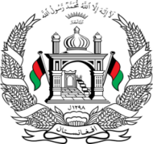
Permanent Mission of Islamic Republic of Afghanistan
36th Session of the UPR Working Group

Statement on the Review of Maldives

4 November 2020 at 14:30

Mr./Mme. (Vice) President,

Afghanistan welcomes the distinguished delegation of the Republic of Maldives to this UPR Session. We express our appreciation for their engagement with the UPR and for their efforts to fulfill their human rights obligations since the previous cycle.

We commend progress made to address problems related to trafficking in persons, the increase in school enrollment rates, and the achievement of almost universal participation at the primary, secondary and lower-secondary levels,

Mr./Mme. (Vice) President,

We remain concerned about the adequacy of legal frameworks protecting women, children, refugees and asylum seekers,

In the spirit of constructive engagement, we wish to make the following recommendations:

(1) Develop a national refugee protection framework by adopting administrative measures and establishing institutions capable of handling asylum issues

(2) Ratify the Optional Protocol to the Convention on the Rights of Persons with Disabilities

Finally, Afghanistan encourages the Republic of Maldives to continue to promote and protect human rights in the context of COVID-19 and wishes Maldives every success in the UPR review process.

I thank you, Mr./Mme. (Vice) President.

