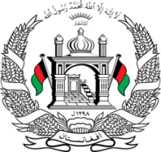
Permanent Mission of Islamic Republic of Afghanistan
36th Session of the UPR Working Group

Statement on the Review of Croatia

10 November 2020 at 9:00

Madam President,

We welcome the distinguished Croatian delegation and express our appreciation for the significant progress made since the previous cycle. In particular, Afghanistan welcomes the high female enrollment rate in secondary and tertiary education, the adoption of a law on protection against domestic violence, the improvements in the electoral system regarding the participation of Roma and Sinti in public and political life, and the adoption of the Strategy for Combating Poverty and Social Exclusion.

Madam President,

While acknowledging the progress, in the spirit of constructive engagement, we wish to make the following recommendations:

- Ensure effective access of persons in need of international protection to the territory and to a fair and efficient asylum procedure.
- Continue to follow up on reports of mistreatment and excessive use of force at the borders, including through effective and independent monitoring and investigation, and take action to prevent such incidents from recurrence.
- Improve reception conditions for vulnerable children including through establishing appropriate reception facilities, and upholding the best interests of the child in the course of any immigration proceedings.

Finally, we wishe Croatia every success in the UPR review process.

I thank you, Mme President.

