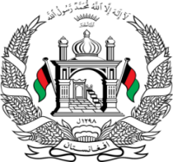
Permanent Mission of Islamic Republic of Afghanistan
36th Session of the UPR Working Group

Statement on the Review of Bulgaria

6 November 2020 at 9:00

Mr./Mme. (Vice) President,

Afghanistan welcomes the distinguished delegation of the Republic of Bulgaria. We express our appreciation for their engagement with the UPR and for their positive developments since the previous cycle.

Mr./Mme. (Vice) President,

Afghanistan welcomes progress in school attendance and the progress achieved in child-care system reform,

We remain concerned about incidents of hate speech and hate crime, and the decreasing net enrolment rates at the preschool and primary school levels,

In the spirit of constructive engagement, we wish to make the following recommendations:

(1) Ensure that social benefits reach those in need and adopt targeted measures to keep children out of poverty to advance the achievement of SDG 1

(2) Take measures to improve the conditions of reception centers for asylum seekers, including by providing adequate food and essential non-food items, with particular attention paid to the reception of children seeking international protection

Finally, Afghanistan encourages Bulgaria to continue to promote and protect human rights in the context of COVID-19 and wishes Bulgaria every success in the UPR review process.

I thank you, Mr./Mme. (Vice) President.

