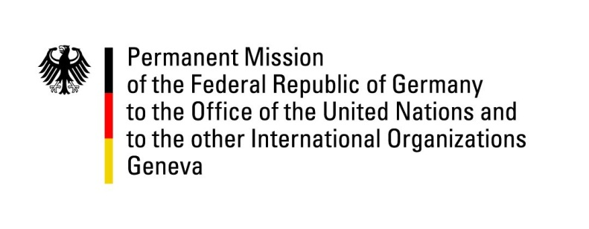

**United Nations Human Rights Council**

**36th Session of the UPR Working Group**

**Geneva, 3rd November 2020**

**German Recommendations and advance questions to**

**Panama**

Speaker:

Fridtjof Dunkel

[Pol-1-io@genf.diplo.de](mailto:Pol-1-io@genf.diplo.de)

Tel: 079 821 32 37

Madam President,

Germany welcomes the delegation of Panama.

We commend Panama for its efforts to end gender inequalities with a special regard to the gender-specific needs of women, including in the area of education.

Germany remains concerned about prison overcrowding and would like to encourage Panama to engage more actively in the protection of vulnerable groups, such as women and LGBTI.

Germany therefore would like to make the following recommendations:

1. Take measures to address prison overcrowding, including by offering alternatives to imprisonment, such as community service, weekend arrest or house arrest,
2. Strengthen the protection of women against sexual and gender based violence, including by applying the existing respective legal instruments, by prosecuting and, if convicted, punishing the perpetrators and by creating an appropriate number of accommodations for survivors of gender based violence as well as ensuring their police protection,
3. Combat arbitrary treatment of as well as physical and psychological violence against lesbian, gay, bisexual, transgender and intersex persons by members of the security forces, adopt legislation to explicitly prohibit discrimination on the grounds of sexual orientation or gender identity and punish those who practice such discrimination.

Thank you, Madam President.

**GERMAN ADVANCE QUESTIONS TO PANAMA:**

* Prisons in Panama continue to be overpopulated. This may lead to an increase in violence, as the fight between armed gangs in La Joyita prison in December 2019 has shown. What is the Government of Panama undertaking to reform the penitentiary system and reduce overpopulation in prisons?