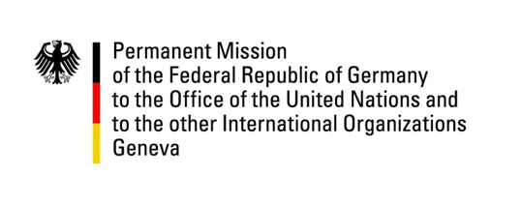

United Nations Human Rights Council
36th Session of the UPR Working Group
Geneva, 4th November 2020

---
Recommendations to
Mongolia

Madam President,
Germany welcomes progress made by Mongolia since its last UPR, in particular the changes made in the national criminal code in order to align the definition of torture with the one in the CAT, and new provisions that allow for compensation and rehabilitation of victims of torture.
We commend improvements concerning the Rights of the Child and the progress towards reducing child labour as well as the prohibition of corporal punishment.
We call upon the government of Mongolia to further improve the protection of human rights defenders and to ensure civic space.
We recommend Mongolia to:
- take further measures against child labour and against domestic and sexual violence against children inter alia by increasing funding for prevention programmes in this regard,
- adopt an effective data protection legislation to better protect and promote the right to privacy according to the principles of legality, necessity and proportionality,
- protect human rights defenders by strengthening and adopting the draft law on human rights defenders in line with the recommendations by the SR on Human Rights Defenders,
- revise the draft law on NGOs to ensure its provisions on registration and financing comply with international standards.

Thank you, Madam President

