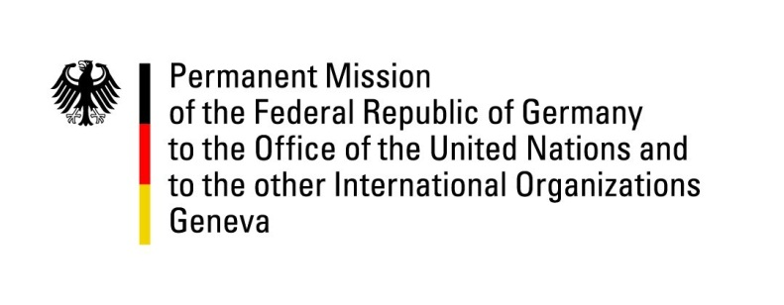

United Nations Human Rights Council

36th Session of the UPR Working Group

Geneva, 9th November 2020

German Recommendations to
Marshall Islands

Madame President,
Germany welcomes the delegation of the Government of the Republic of the Marshall Islands and appreciates its progress since the last UPR. We commend the Marshall Islands particularly for their engagement as a member of the UN Human Rights Council since January 2020.

We acknowledge the major challenges that the Marshall Islands are encountering resulting from the effects of climate change. Germany appreciates and supports the advocacy for this global concern that requires firm and joint actions. Germany also welcomes the ratification of several important international conventions such as CAT, CCPR, CESCR and CERD.

However, Germany remains concerned about the lack of systematic and adequate implementation of minority rights as well as the rights of women and children.

Therefore, Germany recommends the Republic of the Marshall Islands to:
- entirely prohibit corporal punishment of children inter alia by amending the Criminal Code of 2011,
- establish an independent national human rights institution in accordance with the Paris Principles,
- implement a systematic approach to enhance measures of collecting statistical data on gender-based violence against women, including domestic violence,
- Ratify the CED, the Second Optional Protocol to ICCPR and the OP-CAT.

Thank you, Madame President.

