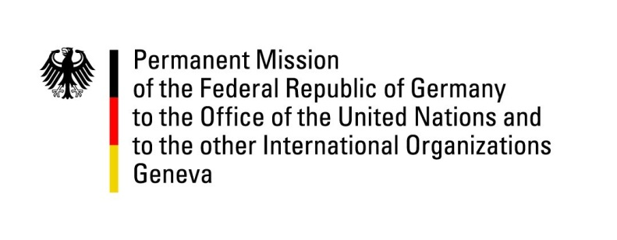

United Nations Human Rights Council

36th Session of the UPR Working Group

Geneva, 4th of November 2020

German Recommendations to
Maldives

Madame President,
Germany welcomes the delegation of the Government of the Maldives and the progress made by it since the last UPR.
Germany commends the Maldives for its efforts in further developing and fortifying the democratization processes and its acknowledgement of the necessity to tackle religious radicalization.

Germany remains however concerned about some recent developments, in particular regarding civil society space.

Germany therefore recommends to:
- enable human rights defenders to work freely and conduct a transparent and public investigation on the ban of the Maldivian Democracy Network (MDN),
- continue to combat violent religious extremism and establish secure contact points for victims of hate speech and hate crimes,
- ratify the Second Optional Protocol to the ICCPR and the CED,
- adopt specific legislation to criminalize marital rape without any exemptions and undertake legislative reforms to prevent domestic violence against women.

Thank you, Madame President.

