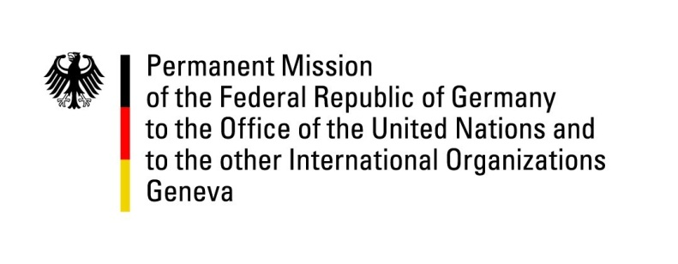

United Nations Human Rights Council

36th Session of the UPR Working Group

Geneva, 3rd November 2020

German Recommendations and advance questions to
Republic of Malawi

Madam President,
Germany welcomes the delegation of Malawi to the third cycle of the UPR and appreciates that civil society has been transparently included in its preparation.

We welcome the efforts the new government has undertaken to fight violence against people living with albinism. However, we are deeply concerned that since 2019 there have been ten death sentences in albinism cases.

Germany would like to offer the following recommendations to the Government of Malawi:
- Intensify existing measures to improve prison conditions and ensuring access to health and sanitary facilities for inmates,
- Increase support for reproductive health and family planning services and access to affordable contraceptives and contraceptive methods,
- Take all reasonable measures to review and ratify all outstanding international HR conventions, including the Second Optional Protocol to the International Covenant on Civil and Political Rights, aiming at the abolition of the death penalty,
- Enhance the protection of children, especially by implementing laws on child marriage and by strengthening accountability in cases of sexual abuse, child labor and trafficking.

Thank you, Madam President.

GERMAN ADVANCE QUESTIONS TO THE REPUBLIC OF MALAWI
- Which strategy does the new government pursue in order to combat corruption in Malawi efficiently? Will there be an Action Plan or other legal frameworks (e.i. a “Corrupt Practices Act”) in order to address the topic in all parts of the society and sensitize them for prevention?
- What measures has the Government of Malawi taken and is planning to take in order to end sexual violence and exploitation of women and children? How does the Government of Malawi intend to strengthen the rights of women and girls to education and access to the labor market?
- Considering that there have not been any sentences since 2012, does the new government consider reviewing laws that impede rights of LGBTI, for example, provisions criminalizing consensual same-sex sexual conduct? What efforts does the government undertake in order to promote acceptance of LGBTI persons within the society?

