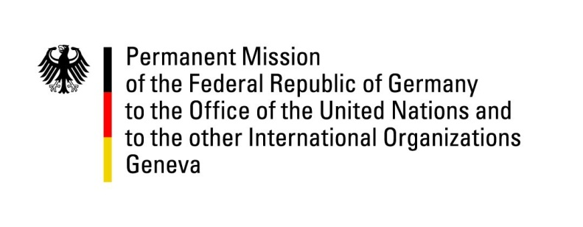

United Nations Human Rights Council

36th Session of the UPR Working Group

Geneva, 11 November 2020

Recommendations and advance questions to
Libya

Madame President,
Germany welcomes the delegation of Libya to the UPR. We remain very concerned about the human rights situation across Libya. While this review addresses the Government of National Accord, we wish to reiterate that all parties to the conflict bear a responsibility for upholding human rights in Libya.

Germany recommends:
- Ratify the Convention relating to the Status of Refugees and its Protocol and adopt an appropriate domestic legal framework for the protection of the rights of refugees and asylum-seekers as well as other migrants and IDPs.
- Ratify the Convention for the Protection of all Persons from Enforced Disappearances (CED).
- Ensure protection of human rights defenders, journalists and political activists, in particular women, from cases of arbitrary arrests and enforced disappearances.
- Ensure that all detained persons have access to formal judicial processes and that minimum standards for their treatment are respected.
- Guarantee full cooperation with FMM established by HRC.

Thank you, Mr. President.
GERMAN ADVANCE QUESTIONS TO LIBYA:
- How will the Government of National Accord ensure comprehensive access and full cooperation of all relevant actors with the Fact Finding Mission established by the Human Rights Council?
- What efforts has the Government of National Accord undertaken in order to ensure accountability and a judicial follow-up after the finding of mass graves in the city of Tarhouna? How will it support the investigations of the ICC in this regard?
- How will the Government of National Accord ensure that Civil Society Organizations are able to work freely and without oppression?
- What measures has the Government of National Accord implemented in order to facilitate the return and full enjoyment of civil, political as well as economic, social and cultural rights by internally displaced persons?

