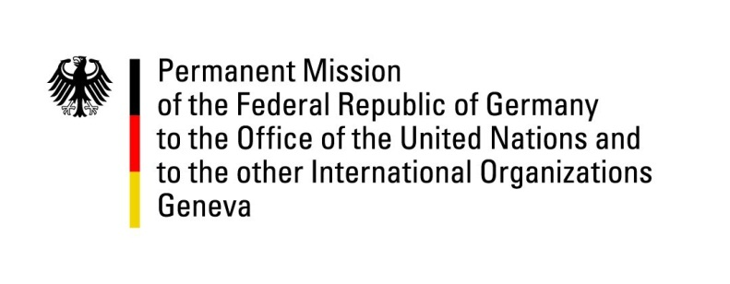

United Nations Human Rights Council

36th Session of the UPR Working Group

Geneva, 2nd November 2020

German Recommendations and advance questions to
Republic of Liberia

Madam President,
Germany welcomes the delegation of the Republic of Liberia.

We commend of the Republic of Liberia for its credible, free, fair and democratic 2017 Presidential and Parliamentary Elections and the ensuing transfer of power from one democratically elected leader to another. An important democratic milestone indeed - and also the benchmark for the upcoming senatorial midterm elections next month.

Liberia’s enforcement of constitutional and legal frameworks does remain an issue of concern though.

Germany recommends to:
- address and implement the recommendations made by the Truth and Reconciliation Commission in its December 2009 Final Report , notably to operatively embrace the question of the establishment of the suggested War and Economic Crimes Court and other transitional justice issues,
- adopt and effectively implement legislation that criminalizes all forms of female genital mutilation, without exception,
- ratify the Second Optional Protocol to the International Covenant on Civil and Political Rights, aiming at the abolition of the death penalty,
- effectively implement the National Action Plan to combat child labour and enforce the provisions on forced labour in the Penal Code and the provisions on mandatory primary education in the Children’s Law.

Thank you, Madam President.
GERMAN ADVANCE QUESTIONS TO THE REPUBLIC OF LIBERIA
- Could the Government of the Republic of Liberia elaborate on the current state of the implementation of the recommendations made by the Truth and Reconciliation Commission (TRC) which were issued in 2009 but remain to be established successfully to date. Could the Republic of Liberia additionally elaborate on its further endeavor to implement these recommendations?
- The Republic of Liberia is a State party to the Second Optional Protocol to the ICCPR since 2005. Is the Republic of Liberia planning on taking steps toward the abolition of death penalty?
- The Republic of Liberia has accepted recommendations during the previous UPR to improve and reform the criminal justice sector for example with regard to overcrowding, the shortage of judges, prosecutors and public defenders as well as corruption. Could the Republic of Liberia elaborate on the current state of the implementation of the recommendations?

