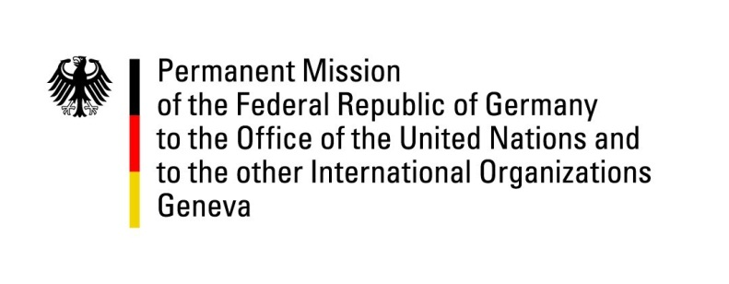

United Nations Human Rights Council

36th Session of the UPR Working Group

Geneva, 5th November 2020

German Recommendations and advance questions to
Honduras

Speaker:
Fridtjof Dunkel
Pol-1-io@genf.diplo.de
Tel: 079 821 32 37
Madame (Vice-)President,
Germany commends Honduras for creating a Human Rights Ministry in 2018 and the Ministry’s efforts so far.

However, we regret having to repeat some of our concerns already expressed in 2015 and remain concerned about widespread impunity.

Therefore, Germany recommends to:
- substantially improve efforts to effectively protect journalists, human rights defenders and environmentalists as well as vulnerable groups such as women, youth, LGBTI and indigenous people, including by effectively combating impunity,
- to involve civil society organisations in the decision-making of the National Protection Mechanism,
- following the end of MACCIH’s mandate, build on the progress achieved and to strengthen institutional capacities for fighting corruption, including by allocating adequate financial and human resources of the Offices of the Special Prosecutor,
- ensure the independence of the Judiciary, inter alia by introducing that judges cannot be transferred against their will,
- improve equal access to health services, including sexual and reproductive health services,
- take effective measures to bring conditions of detention in line with international standards, in particular by reducing overcrowding and inter-prisoner violence.

We encourage Honduras to investigate the human rights abuses following the elections of 2017 and to take “lessons learned” into account in 2021.

Thank you, Madame (Vice-)President.
GERMAN ADVANCE QUESTIONS TO HONDURAS:
- Impunity for human rights violations is alarming. What measures is the Government of Honduras taking to prevent impunity for human rights violations, including when committed by security forces?
- In the UPR 2015, Germany recommended to “Take additional steps to guarantee equal access for women to appropriate health services, especially sexual and reproductive health services, and ratify the Optional Protocol to the Convention on the Elimination of All Forms of Discrimination against Women” (126.4). We would like to ask a) which concrete measures are being taken to ensure equal access to health care and services for women and b) whether ratification of the optional protocol is under consideration and if not what reasons currently hinder ratification.

