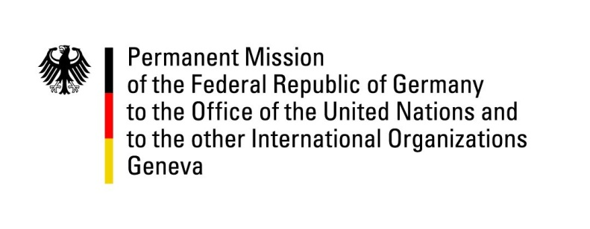

United Nations Human Rights Council

36th Session of the UPR Working Group

Geneva, 6th November 2020

German Recommendations and advance questions to
Republic of Bulgaria

Madame President,
Germany welcomes the delegation of the Republic of Bulgaria.

We commend the Republic of Bulgaria for its efforts to implement human rights for migrants and refugees.

However, Germany remains concerned about some recent developments.

Therefore, Germany recommends to:
- systematically condemn hate crimes and hate speech and ensure that all racially motivated offences are effectively investigated, prosecuted and sanctioned
- criminalize all forms of domestic violence, not only “systematic” forms of violence and include marital rape into the Criminal Code
- refrain from demolishing Roma settlements without offering alternatives such as providing adequate social housing to Roma families
- strengthen the capacity and financial resources of the Ombudsman and bring it into full compliance with the Paris Principles.

Thank you, Madame President.

