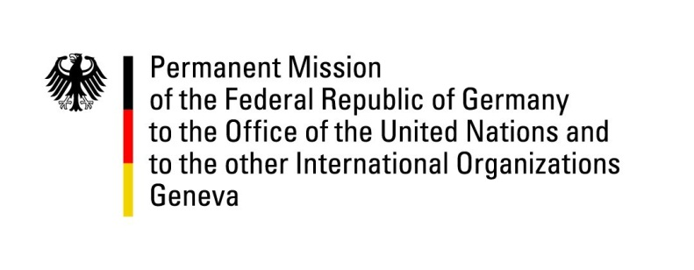

United Nations Human Rights Council

36th Session of the UPR Working Group

Geneva, 5th November 2020

German Recommendations and advance questions to the
Principality of Andorra

Madame President,
Germany welcomes the delegation of the Principality of Andorra and the progress made since the last UPR.

We commend the Principality of Andorra for expanding the mandate of the Ombudsman to also cover the fight against racism and intolerance.

However, Germany remains concerned about the absence of the Principality of Andorra to some international human rights treaties.

Therefore, Germany recommends to:
- Ratify further international human rights treaties such as the International Covenant on Economic, Social and Cultural Rights
- legalize abortion at least in cases of risk to the life of the pregnant woman, rape, incest and severe impairment of the fetus and decriminalize abortion in all other cases
- establish an independent national human rights institution in compliance with the Paris Principles

Thank you, Madame President.

GERMAN ADVANCE QUESTIONS TO the Principality of Andorra:
- Es wurden keine Vorab-Fragen an Andorra gestellt

