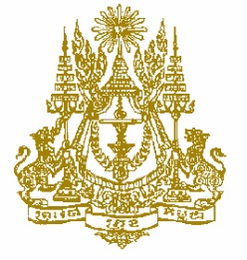
STATEMENT BY CAMBODIA
At the consideration for adoption of the UPR Report of Belarus
36th Session of the UPR Working Group
02 November 2020

Madam President!
- Cambodia recognizes Belarus’s concrete endeavors to fulfill obligations under the treaty body mechanisms, and its cooperation with the special procedure mandate holders.
- Cambodia congratulates the high level achievement of Human Development Index for Belarus’s women in the world.
- Madame President, Belarus’s efforts to increase representation of women in decision-making positions are commendable.
- Cambodia strongly uphold Belarus’s initiative to offer specialized secondary and higher education for persons in correctional institutions.
- However, in the constructive spirit, Cambodia would like to recommend Belarus:
- To continue increase representation of women in the decision-making positions,
- To take additional steps to increase access to preschool education in the rural areas,
- To further scale up the rate of persons deprived of liberty in correctional institutions to receive specialized education through distance learning.
- Finally, I wish the delegation of Belarus every success in this review.
I thank you, Madam President!
----------

