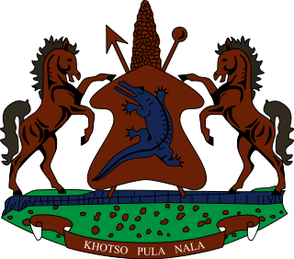
STATEMENT BY LESOTHO DELEGATION DURING THE THIRTY FIFTH SESSION OF THE UNIVERSAL PERIODIC REVIEW WORKING GROUP ON UNITED STATES OF AMERICA
9 NOVEMBER 2020
Thank you, Madam. President,
Lesotho welcomes the delegation of United States to the Working Group. We recognize and appreciate the steps which United States has taken to advance the human rights of its citizens. We comment the United States for developing the 2019 Strategy on Women, Peace, and Security, which seeks to prevent, mitigate and protect women and girls from violence.
Irrespective of notable developments, we wish to make the following recommendations for consideration by the United States. 1. To continue to put in place measures to eradicate racism, xenophobia and all forms of related intolerance across the country. 2. To launch awareness campaigns fostered to put an end to all forms of police brutality.
Finally, we wish United States every success with this UPR cycle.
I thank you Madam President.

