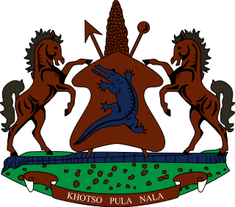
STATEMENT BY LESOTHO DELEGATION DURING THE THIRTY SIXTH SESSION OF THE UNIVERSAL PERIODIC REVIEW WORKING GROUP ON MALAWI
03 NOVEMBER 2020
Thank you, Madam. President,
Lesotho welcomes the delegation of Malawi to the Working Group. We wish to appreciate the efforts made by Malawi to safeguard the human rights of its people in various sectors in the country. We comment Malawi for safeguarding the rights of the child by aligning the Constitution with the Convention on the Rights of the Child (CRC) and the African Charter on the Rights and Welfare of the Child, by raising the age of the child from 16 to 18.
We wish to make the following recommendations for consideration by the delegation of Malawi. 1. To strengthen efforts to fight domestic violence and sexual exploitation of women and children. 2. To bridge a gap between the existence of progressive laws and their implementation thereof.
Finally, we wish Malawi every success with this UPR cycle.

